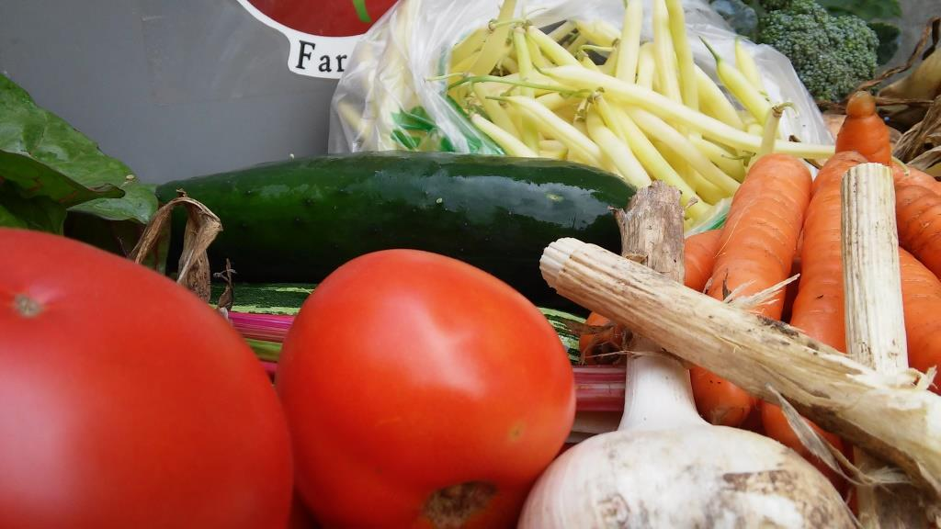

Nineteen weeks of delicious, locally-grown Vegetables delivered every week to a drop site near you!
www.FreshEarthFarms.com
chris@FreshEarthFarms.com
651-436-2778
Community Supported Agriculture from Fresh Earth Farms

